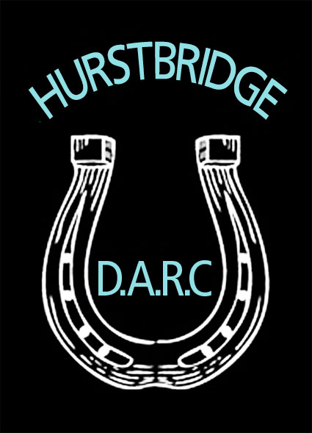

# Summary Insurance – Information for Members

Via our clubs’ affiliation with the HRCAV you as a member of our club have Personal Accident Insurance cover for specified horse related activities.

The premium for this insurance cover is included in your annual fees hence the necessity for you to be a fully financial member at all times when on our grounds or attending any club-based activity.

A copy of the policy is available on the HRCAV Website: [www.hrcav.com.au](http://www.hrcav.com.au) under quick links – 20010/2011 PA Insurance Summary. It is your responsibility to ensure you are familiar with what you are covered for and especially what is NOT covered by your insurance and to ensure you abide by the policies conditions and rules.

The HDARC Committee have briefly outlined the insurance below, but this is just a summary by the committee and shouldn’t be relied on as absolute.

The policy covers riding members for specified horse-related activities as well as non-riding members

The **Cover Conditions** are quite broad however the policy wording is open to interpretation so from an insurance perspective each distinct incident would be judged on its own merits.

The details of the **Cover Benefits** are also available and are quite specific with respect to the amount of benefits paid for particular injuries

The **Policy Exclusions** are also defined in the policy although the definition of some excluded activities is also open to interpretation

Importantly ***it must be noted that members not wearing a helmet at the time of an accident will not be covered***

As a club we are mindful of the conditions of our cover and also the policy exclusions and at all times we will avoid stepping outside these boundaries with the various activities we conduct. As a member you are encouraged by the committee to be familiar with the insurance policy and not to participate in any activity if you do not feel comfortable.

Page 1/2

If a significant injury occurs an incident report form must be completed with a witness declaration if there is a witness available – these are available in the red folder kept at the club-rooms or can be obtained from the club secretary – this then needs to be forwarded to our insurer BJS for a claim form– please first discuss with the club secretary or president before contacting the insurer.

Safety of our riders/horses and spectators is of paramount importance so any incident will be evaluated at committee level with the aim of prevention of a recurrence .

The cover benefits are limited unlike the sort of cover you may be familiar with if you take out private life or accident insurance or income protection insurance.

All members are advised to read the details of the policy so that you are quite clear on the level of cover the policy provides as well as the type of activities that are covered and importantly the exclusions on the policy. You should apply this knowledge to your own personal circumstances in deciding if the cover provided is adequate for your needs. There are other insurances available at your own expense and outside of the HDARC/HRCAV cover such as that provided by the EFA. You may wish to consider additional insurance if you are participating in activities outside the cover conditions of our current HRCAV insurance policy.

To minimise risk we require you to wear an approved helmet at all times (including whilst leading horses), ASA approved boots, a medical armband while jumping and also to observe our other policies and guidelines available on our website, especially “About our Club”

## Public Liability

As well as personal accident insurance cover current HDARC members and the committee have public liability insurance which covers legal liability to pay compensation to third parties in respect of personal injury or property damage

Full details of this policy are available on the HRCAV website and all members are advised to be familiar with this policy.

***October 2012 HDARC Committee Summary***

Page 2/2