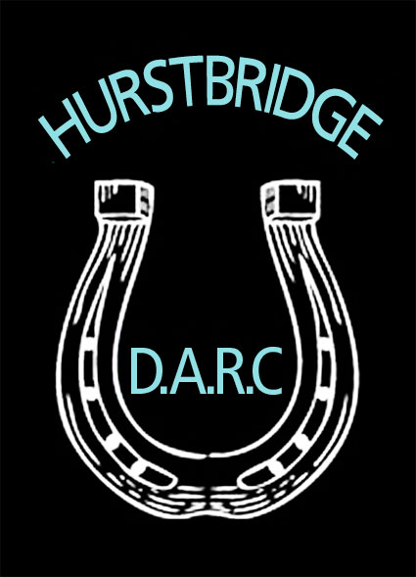

# HDARC Stallion Policy

The HDARC from April 2010 has adopted the guidelines of the HRCAV concerning stallions

For the safety of people and horses at our rallies, events and other club activities all stallion owners or handlers are required to abide by the rule set down by the HRCAV relating to identification, security and control of stallions, rigs and colts at HRCAV events

The rule is as follows:

* Stallions must be contained within a float, truck, stable or steel-yard or be securely double-tied by a headstall and pull back collar and/or hobbles whilst not being ridden or handled.
* Fluoro green plastic discs (available from the HRCAV office) must be displayed on both sides of the stallion or rig on head-gear or saddle blanket and the owners truck or float must display a large green disc
* Stallions and rigs must be wearing a bit when being ridden or led around the venue
* Riders and handlers must be over 17 years of age

We are advised as a club to ensure that all our members are aware of what the green disc means and to keep our horses a safe distance from stallions

Members with stallions are required to follow these safe practices and should be advised of our requirements when joining. If you are unsure about any of the requirements please contact the President BEFORE bringing a stallion to a HDARC rally.

***Hurstbridge District Adult Riding Club September 2010***